Database Maintenance System for Microsoft SQL Server 2008-2014

  - Technical reference

  - Oleg Trutnev
Premier Field Engineer – Database
10.09.2015

System purpose
System has been created to solve the problem of SLA violation during SQL Server Database Maintenance, that often been a reason why some of our customers gave up database maintenance at all. System has necessary capabilities to solve this problem:
- Executes only needed maintenance tasks, evaluating database state
- Prioritizes tasks to ensure the most important tasks are executed
- Predicts execution time
- Keeps the track of time during execution and does not start next task if it probably won’t fit remaining timeframe.

Supported Maintenance Tasks
Current version of system can perform various types of maintenance tasks
Index maintenance:
- Offline index rebuild,
- Online index rebuild (if it is possible due to columns data type, SQL Server version, edition and system settings),
- Index reorganization,
Statistics update
- Update statistics with FULLSCAN,
- With limited SAMPLE,
- With previously used SAMPLE (RESAMPLE).

Integrity checks
- Metadata checks (CHECKCATALOG),
- Allocation checks (CHECKALLOC)
- Single table integrity check (CHECKTABLE)

System components

Overview
System is SQL Server database and a set of SQL Server Agent jobs.
Database name is VBMS (Value Based Maintenance System – because system evaluates every task and executes the most valuable ones first). Database name should not be changed as it is used in code.
SQL Server Agent Jobs can be of three types:
- Tasks generators (FillQueueAll)
- Workers (StartWorker)
- Killers (KillWorker)
Tasks generation can be executed before maintenance time as it does not interrupt normal work.

Tables (some)

dbo.Parameters
Stores global parameters. Different data types stored in three different columns (string_value, int_value, float_value). Each parameter has it’s brief description.

dbo.OperationTypes
Stores the types of operations that system can perform.

dbo.Tasks
The main table in the system. Here the tasks are added and then updated during their execution. Each task is a T-SQL command and a set of metadata, such as operation type, target object, dates when it was added, began and completed, etc.

Fields:
Field | Data type | Description
[entry_id] | bigint | Primary key, increment is 1.
[batch_id] | uniqueidentifier | Unique indetifier of a group of tasks, generated during one execution of FillQueueAll
[subsystem_id] | int | Id of type of work (references dbo.OperationTypes)
[action_type_id] | int | Id of type of action (references dbo.OperationsTypes)
[command] | nvarchar(4000) | T-SQL code to be executed
[date_added] | datetime | Date when task was generated by FillQueueAll
[date_started] | datetime | Date when task was taken by worker
[date_completed] | datetime | Date when task was completed by worker
[duration_s] | int | Time in seconds spent for execution
[database_id] | int | Id of database affected by task
[table_id] | int | Id of a table affected by task
[index_id] | int | Id of an index or statistics affected by task
[partition_n] | int | Number of partition affected by task
[maxdop] | int | Max degree of parallelism used for index maintenance task execution
[user_scans] | int | Number of scans, performed on the index. Taken from sys.dm_db_index_usage_stats
[user_seeks] | int | No longer used.
[user_updates] | int | No longer used.
[rowcnt] | bigint | Number of records, that are stored in a partition or table.
[size_mb] | float | Size of a table, partition, or index.
[ix_frag] | float | Percent of fragmentation
[time_factor] | float | Ratio of size_mb to duration_s. used to predict next execution duration of particular type of task on particular object.
[rowmod_factor] | float | Factor, used to measure how outdated the statistics is.
[checked_daysago] | int | Time since the table has been checked
[result] | nvarchar(max) | Outcome of operation execution. Ok or detailed error message.
[time_prognosis_s] | int | Approximate time that this task can take. Calculated basing on previous executions.
[exit_code] | int | 1 if execution was successful, -1 if not enough time left, -2 if not enough transaction log space left, or exact error number if error occurred.
[worker_name] | nvarchar(50) | Text identifier of a worker, that executed this task.
[execution_id] | uniqueidentifier | Uniqueidentitifier of a group of tasks, executed by same worker during same at one launch.
[priority] | int | Number, sets automatically to lower priority of tasks, faild last time. 1 - normal priority, 2 - low priority

dbo.Workers
Here the task execution profiles are stored. Profile is a set of parameters that are used to control what and how the worker will execute.

Fields:
Field | Data type | Description | Default value
worker_name | nvarchar(255) | Unique profile name
date_added | datetime | Date, when profile has been added. Filled automatically. | getdate()
owner | nvarchar(150) | Who to ask about this profile | John Doe
comment | nvarchar(500) | Description of profile. What is this profile for? ex: AW_Nightly_full_maint | Owner did not add any comment
use_user_db | bit | Perform tasks for user DBs. | 1
use_system_db | bit | Perform tasks for system DBs (and VBMS too). | 0
dbname_list | varchar(500) | List of databases. No spaces allowed. Ex: ‘DB1,DB2,DB3’ | ''
except_list | bit | Invert dbname_list. | 0
indexes | bit | Perform index maintenance tasks | 1
stats | bit | Perform stats maintenance tasks | 1
stats_sample | nvarchar(50) | Sample to use when generate statistics maintenance tasks after index maintenance. Supported values are: SAMPLE # PERCENT, SAMPLE # ROWS, FULLSCAN | FULLSCAN
checkall | bit | Perform any kind of checks | 1
checktable | bit | Perform CHECKTABLE | 1
checkalloc | bit | Perform CHECKALLOC | 1
checkcatalog | bit | Perform CHECKCATALOG | 1
online_only | bit | Do not pick the Offline index rebuild tasks | 1
afterparty | bit | In the end, if we have more than 5 minutes left then we can try to execute skipped tasks of any kind. Or if index maintenance time limit was faced, some index tasks remains and during next phases (statistics maintenance and integrity checks) some time have been saved, then it can be used to perform those index tasks. By default, this feature is on. Do not set it off unless you are sure. | 1
add_stats_runtime | bit | Add statistics maintenance tasks AFTER index operations. This might save up some time, because some statistics will be updated during index rebuild. Without this option a lot of time will be spent for nothing. | 1
totaltimemin | int | Total limit of worker execution time. Overrides TotalMaintenanceWindowMn global parameter.
indextime | int | Percent of totaltimemin that can be spent for index maintenance. Overrides IndexMaintenanceWindowPercent global parameter
stattime | int | Percent of totaltimemin that can be spent for stats maintenance. Overrides StatMaintenanceWindowPercent global parameter
checktime | int | Percent of totaltimemin that can be spent for integrity checks. Overrides CheckWindowPercent global parameter.
latched_spid | int | Flag used to prevent starting FillQueueAll for this worker several times. When FillQueueAll started for a particular worker it places current session_id here. | 0
stoplight | bit | Flag used to prevent worker from taking next task. It's a signal to stop work after current task is completed. | 0

dbo.WorkerSession
Table is used to track current worker activities. Each worker add a record here when started and after each task executed. It is used mainly for killing workers if it is needed.

Fields:
Field | Data type | Description | Default value
record_date | datetime | Timestamp of last update to this record | getdate()
worker_name | nvarchar(255) | Name of a worker, executing tasks
session_id | int | Session_id of a worker
program_name | nvarchar(255) | Program name, taked from sys.dm_exec_sessions
subsystem_id | int | subsystem_id of a current task. If 1 then killing may cause rollback.
entry_id | bigint | Entry_id from dbo.Tasks, that is currently executing
is_afterparty | bit | Is worker in the afterparty phase. | 0

dbo.DBCCChecksLog

Table is used to store output of DBCC checks. When DBCC command found any errors it outputs them here. Most of the fields are inherited from DBCC CHECK[TABLE, ALLOC, CATALOG] WITH TABLERESULTS.

Fields:
Field | Data type | Description | Default value
rec_id | int | Primary key
execution_guid | uniqueidentifier | Unique identifier. Same for records generated during one DBCC launch. Not related to any fields in dbo.Tasks
log_date | datetime | Date and time when check has been executed
All other fields are from standard DBCC output.

dbo.Blacklist
This table stores records of all actions that should not be taken. You can blacklist any kind of maintenance task for any kind of objects. Each record represents a rule, described as subsystem_id, actiontype_id, database_id, table_id and index_id. NULL is used as *. To add any blacklist items there is a stored procedure dbo.AddBlacklistItem. Rules can be enabled or disabled.

Fields:
Field | Data type | Description | Default value
item_id | bigint | Primary key
date_added | datetime | Date when rule was added | getdate()
database_id | int | Id of a database
table_id | int | Object_id of a table
index_id | int | Id of an index or a statistic
partition_n | int | Number of a partition
subsystem_id | int | Id of subsystem to blacklist (refers to dbo.OperationsTypes)
actiontype_id | int | Id of action type to blacklist (refers to dbo.OperationsTypes)
enabled | bit | Flag to enable/disable rule | 1

Stored Procedures

dbo.FillQueueAll
SP for maintenance tasks generation. It evaluates chosen DB’s and adds suitable maintenance tasks to dbo.Tasks table. In fact this SP is wrapper for a set of procedures dbo.FillQueueXXX.

Parameters
Parameter | Data type | Description | Default value
worker_name | nvarchar(50) | Generate tasks only for a specific worker profile | NULL
indexes | bit | Generate tasks for index maintenance | 1
stats | bit | Generate tasks for statistics maintenance | 0
stats_sample | nvarchar(50) | Sample size used, when generating statistics maintenance tasks | FULLSCAN
checkall | bit | Generate all sorts of DBCC check tasks. | 1
checktable | bit | Generate DBCC CHECKTABLE tasks | 1
table_max_size_mb | int | Maximu size (Mb) of a table that can be checked by DBCC CHECKTABLE | 1000000
checkalloc | bit | Generate DBCC CHECKALLOC tasks | 1
checkcatalog | bit | Generate DBCC CHECKCATALOG tasks | 1
use_user_db | bit | Generate tasks for user databases | 1
use_system_db | bit | Generate tasks for system databases | 0
dbname_list | nvarchar(500) | Generate tasks for list databases | ''
except_list | bit | Turns dbname_list into exception list | 0
sortintempdb | bit | Use tempdb for sorting during index maintenance. Overrides values, stored in dbo.Parameters | NULL
ix_maxdop | bit | Maximum number cores, used for index maintenance. Overrides values, stored in dbo.Parameters | NULL

CHECKALL
This flag combines the three flags – checktable, checkalloc and checkcatalog. Each of this three flags can override CHECKALL flag.

Usage
exec dbo.FillQueueAll @checkall = 0, @checktable =1, @dbname_list = ‘AdventureWorks2008R2,DB1’
This will generate index maintenance and table integrity check tasks for AdventureWorks2008R2 and DB1 databases.
Procedure removes all incomplete tasks for corresponding objects before generating new one to avoid duplication and execution of outdated tasks.
Procedure returns the batch_id which is same for all tasks generated.

dbo.FillQueueCheckAlloc

SP for generation of CHECKALLOC tasks. Used by FillQueueAll. No direct usage is advised.

dbo.FillQueueCheckCatalog

SP for generation of CHECKCATALOG tasks. Used by FillQueueAll. No direct usage is advised.

dbo.FillQueueCheckTable

SP for generation of CHECKTABLE tasks. Used by FillQueueAll. No direct usage is advised.

dbo.FillQueueIndex

SP for generation of index maintenance tasks. Used by FillQueueAll. No direct usage is advised.
Considers many factors to propose best types of operations possible.

dbo.FillQueueStat

SP for generation of statistics maintenance tasks. Used by FillQueueAll. No direct usage is advised.
Uses dynamic threshold as TF2371.

dbo.ProcessQueueAll

Procedure is used inside of SP StartWorker for execution of previously generated tasks.
Most of parameters are taken from dbo.Workers.
SP loops through dbo.Tasks and picks them one after another. Tasks are filtered by parameters provided.

Operation cycle:
There are four phases:
- Index maintenance
- Stats maintenance
- Integrity checks
- AfterParty if enough time left.
During each phase tasks are sorted specific way. For example – during index maintenance phase fist chosen task will be for the index that is most used for scan, heavily fragmented and largest.
For stats the rowmodfactor is used. It shows how hard stats is outdated based on dynamical threshold. For example, 200 means that the statistic is twice more outdated than threshold for it.
Integrity check tasks are sorted by days since last known check. Last known means last found in dbo.Tasks table.

Before executing each task, time left is evaluated. The previous executions of this kind of tasks against this object are used to predict how much time will be spent for this object this time. If prognosis shows that this task may need more time than we have then it is skipped.
Also the free space for transaction log is checked. See dbo.Parameters for details.
If task has been deadlocked it will be retried during afterparty as well as any skipped tasks if we have enough time during this phase. That may occur if stats and integrity check tasks haven’t use all their time.

dbo.StartWorker

SP starts the execution of tasks in a queue. Parameter @worker_name is a name of saved profile from table dbo.Workers.

dbo.KillWorkers

SP stops the execution of selected workers one by one. It is mainly an emergency mechanism.
Uses info from table dbo.WorkerSession. If worker executes index maintenance task (subsystem = 1) then SP switches to the next worker, as killing index maintenance task may cause long rollback. This behavior is changed by @force parameter.
Parameters:
Parameter | Data type | Description | Default value
worker_names | nvarchar(500) | Worker names to be killed without spaces. Ex: ‘Worker1,Worker2,Worker3’ | ''
except_list | bit | Reverse worker_names selection. | 0
force | bit | Kill workers even if there are index operations in progress | 0

dbo.AddBlacklistItem
Procedure is used to add new rules to dbo.Blacklist table. Rules can be added through specifying all the parameters to identify blacklisted tasks or by specifying just entry_id from dbo.Tasks, which means to blacklist that kind of tasks. Blacklisted tasks won’t be generated anymore. Rules can be enabled or disabled using [enabled] column.

Parameters:
Parameter | Data type | Description | Default value
entryid | bigint |  | NULL
database_id | int |  | NULL
table_id | int |  | NULL
index_id | int |  | NULL
partition_n | int |  | NULL
subsystem_id | int |  | NULL
action_type_id | int |  | NULL

Usage:
Let’s say, for some reasons we don’t want to perform any kind of maintenance operations on a table Sales.SalesOrderDetail in database AdventureWorks2014. Then we need to perform such a query:
USE [AdventureWorks2014]

DECLARE @db int = (SELECT DB_ID()),
@tbl int = (SELECT object_id('Sales.SalesOrderDetail'))

exec VBMS.dbo.AddBlacklistItem
@database_id = @db,
@table_id = @tbl,
@index_id = NULL, --all indexes
@partition_n = NULL, -- all partitions
@subsystem_id = NULL, -- all subsystems
@action_type_id = NULL -- all types of actions

Or, if we have to block only update statistics on this table and we have this kind of task in dbo.Tasks previously generated under entry_id 123456, then we can just use this kind of query:
exec VBMS.dbo.AddBlacklistItem @entry_id = 123456

And you will not see this kind of tasks anymore. dbo AddBlacklistItem will just take all the parameters from the specified record of dbo.Tasks.

Function

dbo.GetTimeFactor
Function is used to make prognosis of execution time for tasks. Not used directly.

How-to

Installation
SQL Server 2008:
Run script VBMS_create.sql in SQLCMD mode.
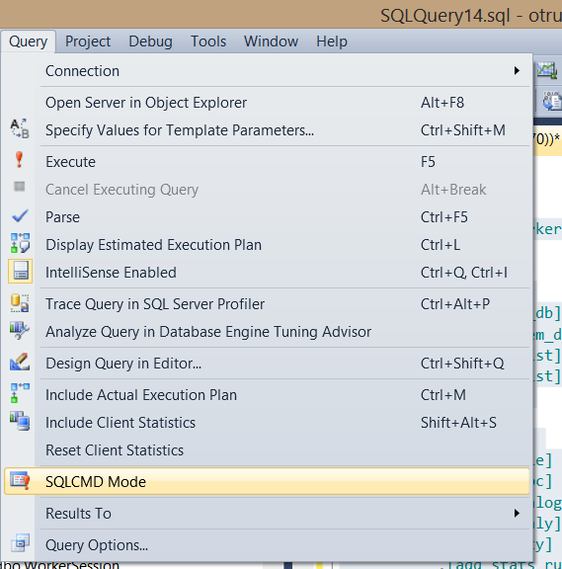
SQL Server 2008R2 and higher
Deploy data-tier application
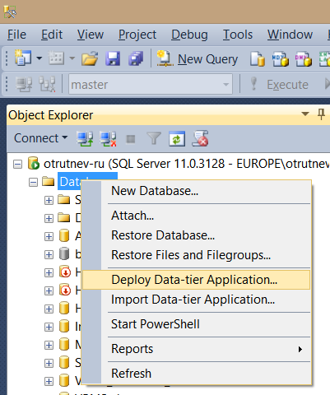

Setup and execution
Open dbo.Parameters table and set all the parameters. Defaults may not work for you.
Then configure tasks generation. Set up a SQL Server job that will execute dbo.FillQueueAll with proper parameters.
Consider we have one DB for maintenance – AdventureWorks. Maintenance can be performed only from 01:00 till 3:00. All sorts of operations allowed at this time.
We configure FillQueueAll to run every day at 00:00 not to use maintenance time for analysis. Filling queue and processing it is two different tasks and they are not really connected. We might collect all sorts of tasks and then execute only those we want. We can have one FIllQueueAll job and 5-6 StartWorker jobs, that will perform different tasks from queue.

Step of job should look like:
EXEC [dbo].[FillQueueAll]
@indexes = 1,
@checkall = 1,
@use_user_db = 1,
@dbname_list = N'AdventureWorks'
It is useful to include step output in history. There batch_id can be found then.
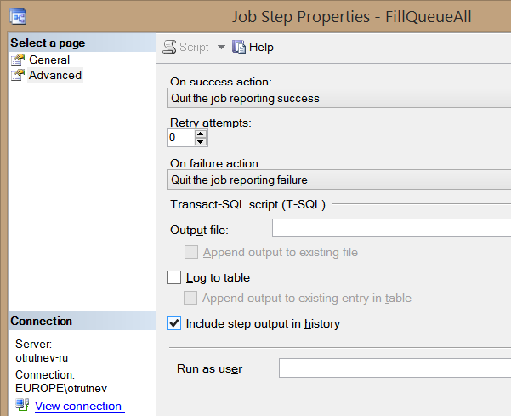

Next step is to configure worker. That means we add a record to dbo.Workers table. Here we chose what types of tasks and how will be executed by the worker. All the bit parameters have defaults.
In our case, we set:
[worker_name] = ‘AWFullMaint’
[owner] = ‘John Doe’
[comment] = ‘AW full maintenance at night only’
[use_user_db] = 1
[dbname_list] = ‘AdventureWorks’
[online_only] = 0
Now, when profile is created, we can use it by worker_name.
Set up a job, that executes
EXEC dbo.StartWorker ‘AWFullMaint’
every night at 01:00.

As we have only 2 hours for maintenance tasks (01:00 – 03:00) we must limit the execution time to 2 hours. We have two options:
- Set the global parameters at dbo.Parameters,
- Set these parameters in worker profile in dbo.Workers.

To be sure that we won’t violate SLA we can configure KillWorkers job.
Create a job, that executes EXEC dbo.KillWorkers @worker_names = ‘AWFullMaint’
@force flag can used to allow killing with possible index operations rollback. However, it is not recommended.

That’s it. We’re good to go.

Execution history analysis
dbo.Tasks table can be used for all sort of analysis. Here we can find what tasks has been executed when and how long it took.
If we just added tasks and want to see what’s been added we can take batch_id from job history
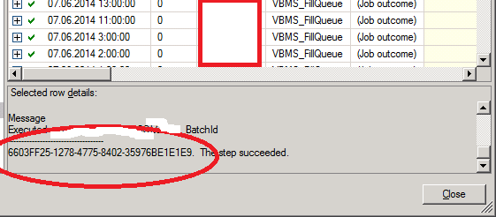
and execute:
USE [VBMS]
GO
SELECT * FROM dbo.Tasks
WHERE batch_id = ‘paste it here’

Error_code can be used for identifying unsuccessful tasks:
USE [VBMS]
GO
SELECT * FROM dbo.Tasks
WHERE error_code <>1

If we want to know how much time took each type of operation during execution we can use this query:
SELECT ot.subsystem_name, ot.action_type_name, SUM(duration_s)
FROM dbo.Tasks dt
JOIN dbo.OperationTypes ot ON dt.subsystem = ot.subsystem_id
AND dt.action_type = ot.action_type_id
WHERE batch_id = 'Paste it here'
GROUP BY ot.subsystem_name
,ot.action_type_name
ORDER BY SUM(duration_s) DESC

